**SHORTEST WIRING PLAN**

**A MINI PROJECT REPORT**

***Submitted by***

**Rishi Varman RT (18C080)**

**Adithya Akilesh Kumar KA (18C004)**

**Shailesh Babu SV (18C094)**

**Yudhish Kumar A (18C125)**

**Shree Shylesh N (18C096)**

**Ritik Singh Jamwal (18C081)**

***as a part of***

**ALGORITHMS LAB (18CS480)**



**THIAGARAJAR COLLEGE OF ENGINEERING MADURAI–15**

**(A Govt. Aided, Autonomous Institution, Affiliated to Anna University)**

**ANNA UNIVERSITY: CHENNAI 600025  
JULY 2020**

**THIAGARAJAR COLLEGE OF ENGINEERING, MADURAI – 625 015**

**(A Govt. Aided, Autonomous Institution, Affiliated to Anna University)**



**BONAFIDE CERTIFICATE**

Certified that this mini project report “**Shortest Wiring Plan”** is the bonafide

work of “**Rishi Varman RT (18C080), Adithya Akilesh Kumar (18C004), Shailesh Babu SV (18C094), Yudhish Kumar A (18C125), Shree Shylesh N (18C096), Ritik Singh Jamwal (18C081)”**

who carried out the mini project work as part of **ALGORITHMS LAB (18CS480)** under my supervision during the Academic Year 2019 - 2020.

|  |  |
| --- | --- |
|  | **Course Instructor**  Mrs. Raja Lavanya  Assistant Professor,  Department of Computer Sc. and Engg.,  Thiagarajar College of Engineering,  Madurai- 625 015 |

**ABSTRACT**

Due to the growing architecture and engineering, buildings have complex interiors nowadays. During the designing of the model of buildings like houses, apartments or schools the electrical wires should be laid and connected from the power source to each room in an optimum manner such that they reach the destination from the main in the shortest route as possible. This activity becomes tedious in case of a complex building.

So, we developed an application called shortest wiring plan which can suggest shortest routes to lay the wiring from the power source to the interior of a building.

The algorithm we used for solving this problem is Dijkstra’s algorithm. It can solve the shortest path problem from a given point to any point. The basic objective of the shortest wiring plan is to find the shortest path between a source and destination.

Our application inputs the source and destination (which are the names of the room inside the building) and outputs the shortest path between the source and destination. This would be useful for designing the electrical wiring route. The wiring path would be more efficient and simpler, so that even if there were any problems in the wiring, it would be an easier task to rectify.

We have considered only a model of a simple house for the application. In future we will improve our application so that it is useful for much bigger buildings such as apartments, schools, colleges etc.

**Content**

|  |  |  |  |
| --- | --- | --- | --- |
| **CHAPTER** |  | **TITLE** | **PAGE NO** |
| **1.** | **Introduction** | | **5** |
| **2.** | **Literature Survey** | | **5** |
| **3** | **Problem Definition** | | **5** |
|  | 3.1 | Introduction |  |
|  | 3.2 | Problem Statement |  |
|  | 3.3 | Problem Description |  |
| **4.** | **Requirements** | | **6** |
|  | 4.1 | Hardware Requirements |  |
|  | 4.2 | Software Requirements |  |
|  | 4.3 | Technologies Used |  |
| **5.** | **Proposed Method** | | **7** |
|  | 5.1 | Existing Solution |  |
|  | 5.2 | Proposed Methodology |  |
|  | 5.3 | Modules |  |
| **6.** | **Implementation** | | **23** |
| **7.** | **Experimental Results and Discussions** | | **29** |
| **8.** | **Conclusion and Future Work** | | **37** |
|  | **References** | | **38** |

**1) INTRODUCTION:**

Due to the growing architecture and engineering, buildings now have complex interiors. In such buildings the electrical connections to the rooms should be done in an efficient way so that the any problem in the circuits can be easily identified. So, we developed an application which can suggest shortest routes to lay the wiring from the power source to the interior of a building.

**2) LITERATURE SURVEY:**

**3) PROBLEM DEFINITION:**

**3.1 INTRODUCTION**

The basic objective of the shortest wiring plan is to find the shortest path between a source and destination. The most classical algorithm for solving such a problem is Dijkstra’s algorithm. It can solve the shortest path problem from a given point to any point.

**3.2 PROBLEM STATEMENT**

To take a real model of a house or building and estimate the optimum wiring distance.

**3.3 PROBLEM DESCRIPTION**

During the designing of the model of buildings like houses, apartments or schools the electrical wires should be laid and connected from the power source to each room in an optimum manner such that they reach the destination from the main in the shortest route as possible. This activity becomes tedious in case of a complex building.

**4) REQUIREMENTS:**

**4.1 HARDWARE REQUIREMENTS:**

**4.2 SOFTWARE REQUIREMENTS:**

* HTML
* CSS
* JAVASCRIPT
* PHOTOSHOP

**4.3 ALGORITHM USED:**

**DIJKTHRA’S ALGORITHM:**

Dijkstra’s algorithm is very similar to Prim’s algorithm for minimum spanning tree. Like Prim’s MST, we generate a SPT (shortest path tree) with given source as root. We maintain two sets, one set contains vertices included in shortest path tree, other set includes vertices not yet included in shortest path tree. At every step of the algorithm, we find a vertex which is in the other set (set of not yet included) and has a minimum distance from the source.

**5)** **PROPOSED METHOD:**

**5.1** **Existing Solution**

Dijkstra Shortest Path Algorithm is an existing solution to find shortest paths between a source and destination.

**5.2** **Proposed Methodology**

The algorithm used here is Dijkstra’s algorithm. The workflow goes by,

* Get the source
* Get the destination
* The shortest route to lay the wire is displayed

Algorithm:

function Dijkstra (Graph, source):

create vertex set Q

for each vertex v in Graph:

dist[v] ← INFINITY

prev[v] ← UNDEFINED

add v to Q

dist[source] ← 0

while Q is not empty:

u ← vertex in Q with min dist[u]

remove u from Q

for each neighbor v of u: // only v that are still in Q

alt ← dist[u] + length(u, v)

if alt < dist[v]:

dist[v] ← alt

prev[v] ← u

return dist[], prev[]

**Limitations and Exclusions:**

We have considered only a model of a simple house for the application

**5.3 Module:**

This web page consists of following module:

**From/Destination:**

In these drop-down boxes, there are the names of the rooms in the house.

**House Plan:**

It displays the model of the house for which we are going to find the shortest path for wiring the electrical circuits

**Path:**

It contains the model of the house and the paths between each of the rooms. When we click the find button, the path which is the shortest path will be highlighted.

**6) IMPLEMENTATION:**

Step 1: Enter from and destination



Step 2: If you click the find button the shortest distance between the from and destination will be highlighted in the diagram

For Example:

If you choose the from as Main and destination location as Hall 2, Then nearest route to the hall from main will be displayed.

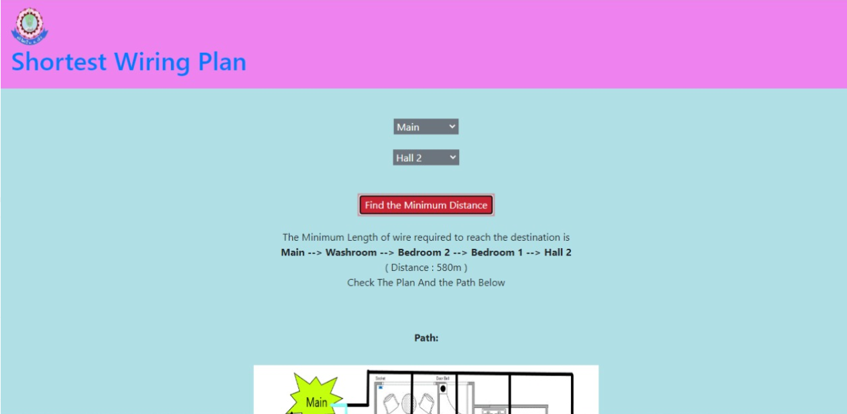

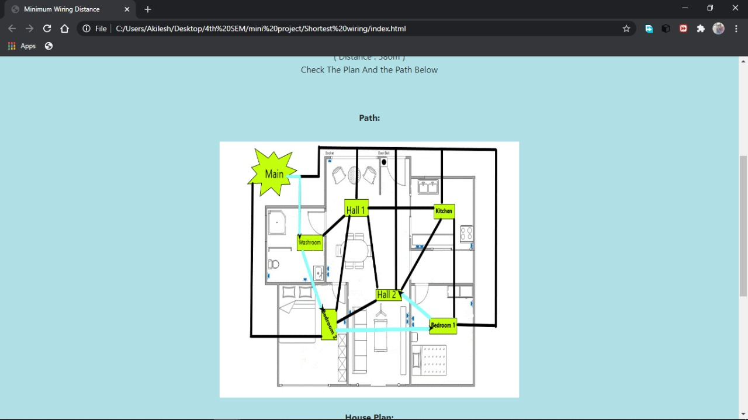Step 3: The below diagram shows the shortest path from main to hall 2

**7) EXPERIMENTAL RESULTS AND DISCUSSION:**

Thus, a web application has been built, which provides the shortest path between two rooms in a building. It will help the people who design the building models to plan the wiring path easily and efficiently.

**8) CONCLUSION AND FUTURE WORK:**

The purpose of this report is to find the shortest path between two rooms in a building We have considered a simple model of a house for the application. In future we will improve our application so that it is useful for much bigger buildings such as apartments, schools, colleges etc.

**References used:**

* <https://medium.com/@yk392/dijkstra-algorithm-key-to-finding-the-shortest-path-google-map-to-waze-56ff3d9f92f0>

* [https://medium.com/@yk392/dijkstra-algorithm-key-to-finding-the-shortest-path-google-map-to-waze-56ff3d9f92f0#:~:text=Dijkstra's%20algorithm%20(or%20Dijkstra's%20Shortest,and%20published%20three%20years%20later.](https://medium.com/@yk392/dijkstra-algorithm-key-to-finding-the-shortest-path-google-map-to-waze-56ff3d9f92f0" \l ":~:text=Dijkstra's%20algorithm%20(or%20Dijkstra's%20Shortest,and%20published%20three%20years%20later.)